Homework 4:
In homework 4, I first design the full adder in matlab Simulink and use this block to design a ripple carry adder. After designing, I generate VHDL code and install it DE-soc1 board.
Screenshot of MATLAB circuit:
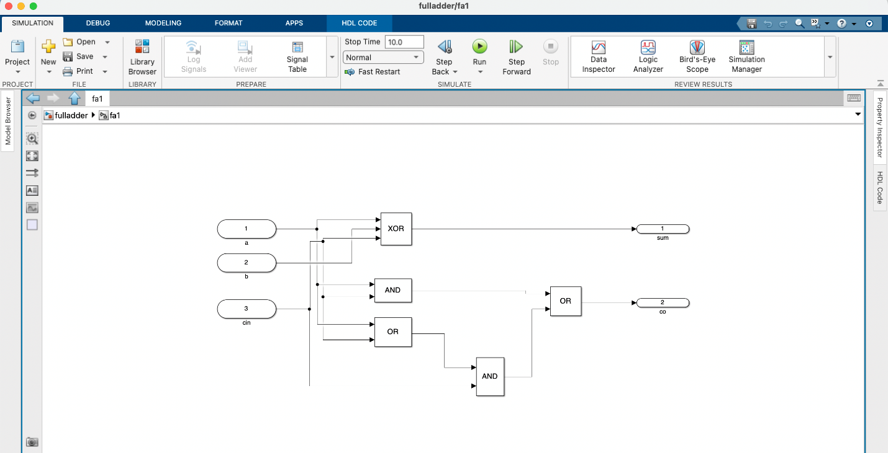
Figure: full adder in MATLAB Simulink
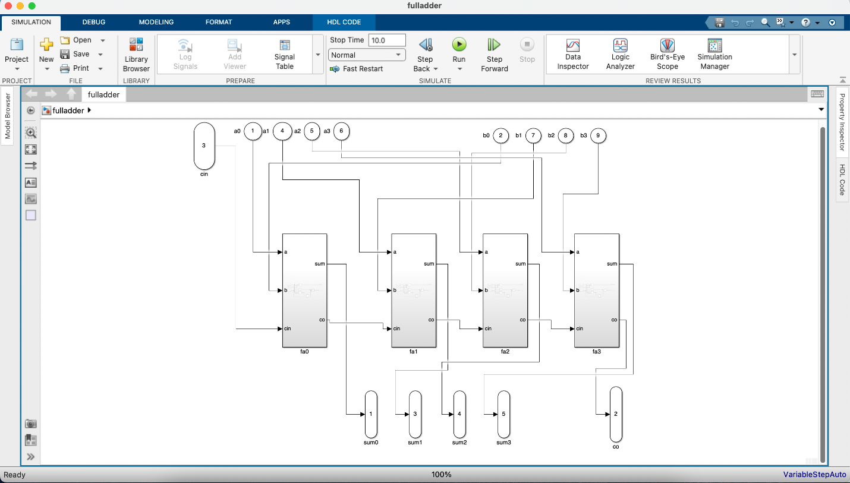
Figure: ripple carry adder in MATLAB Simulink
The generated VHDL codes screenshots are below:
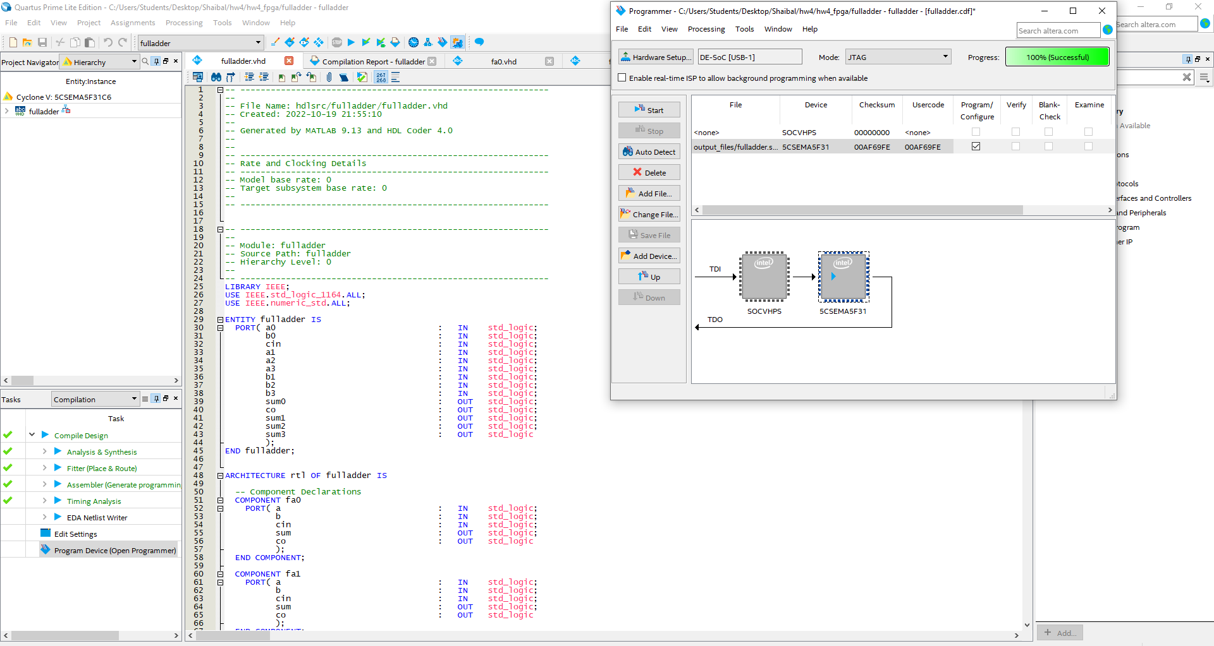
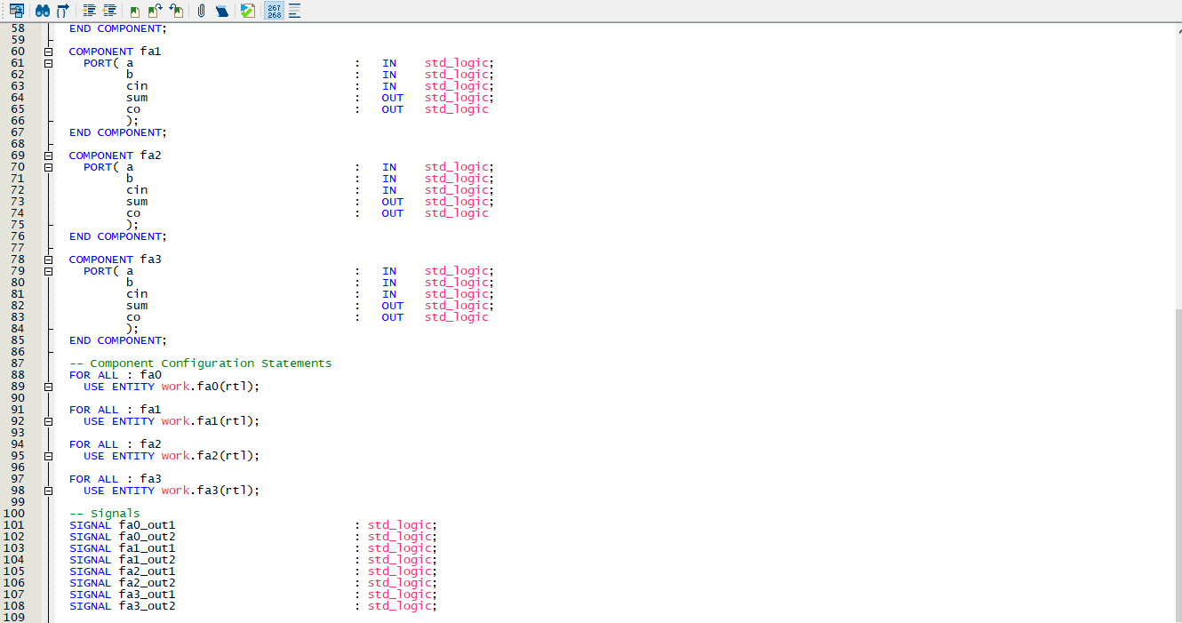
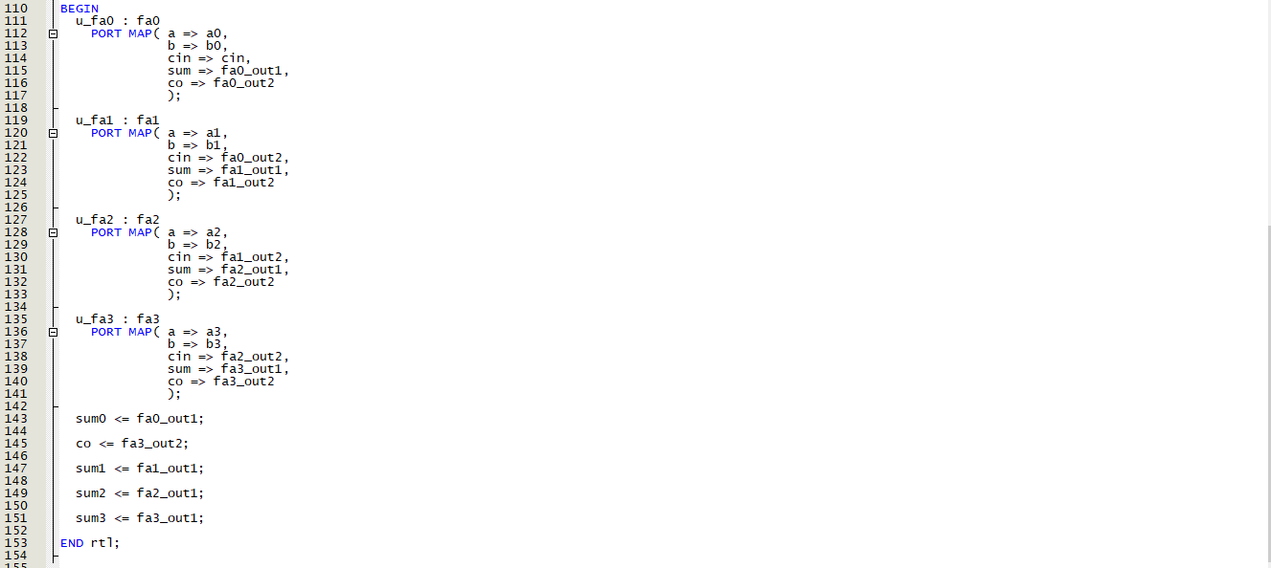
Figure: ripple carry adder main function generated from MATLAB Simulink
The following fa0,fa1,fa2,fa3 full adder blocks functions are below:
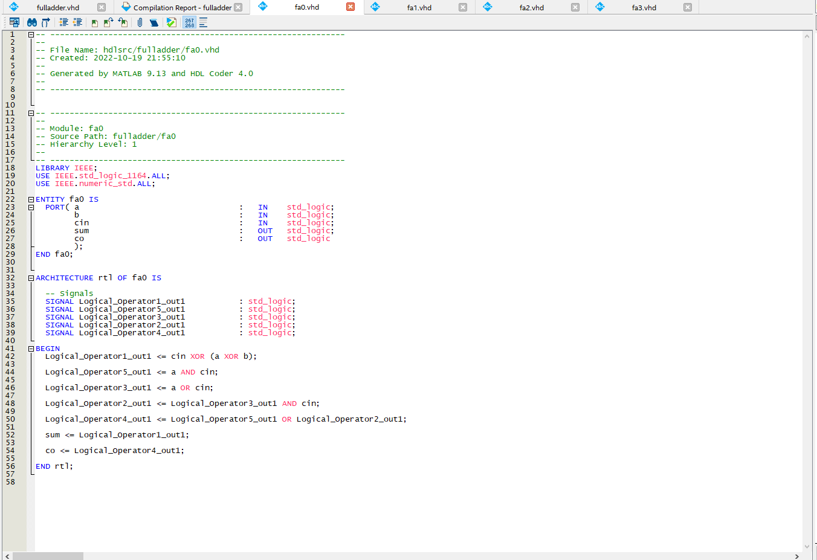
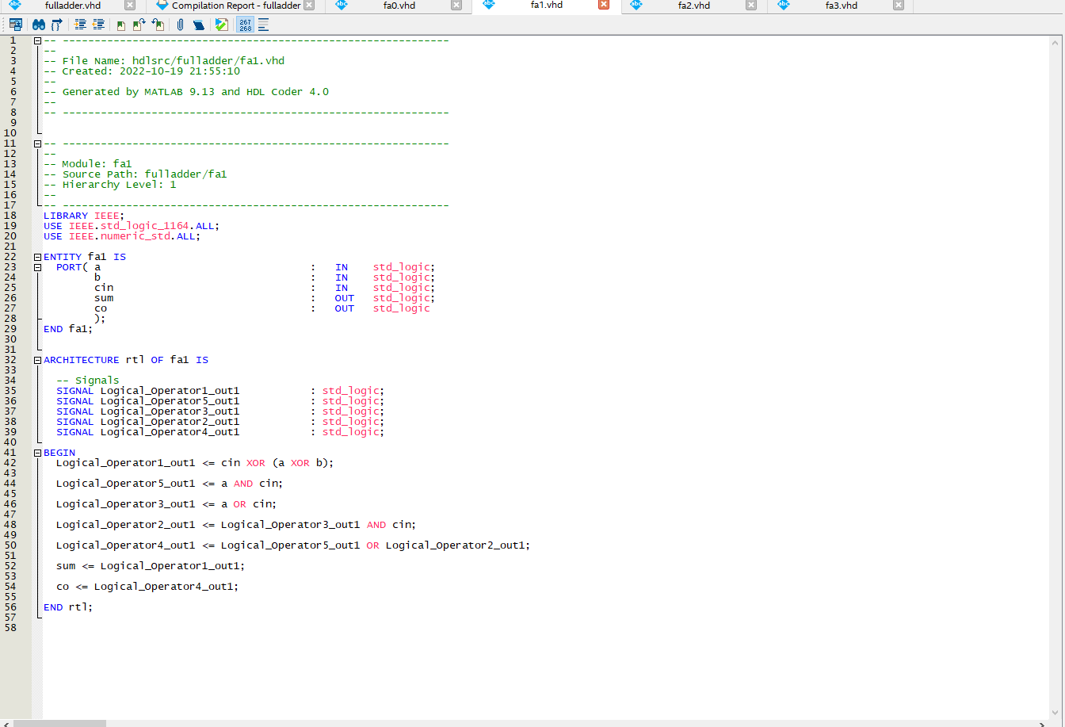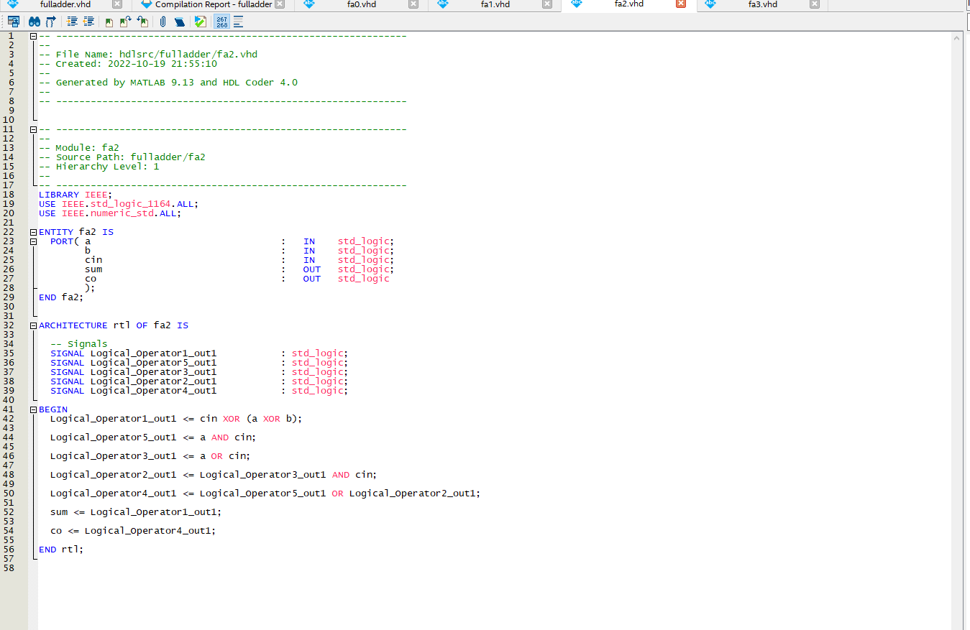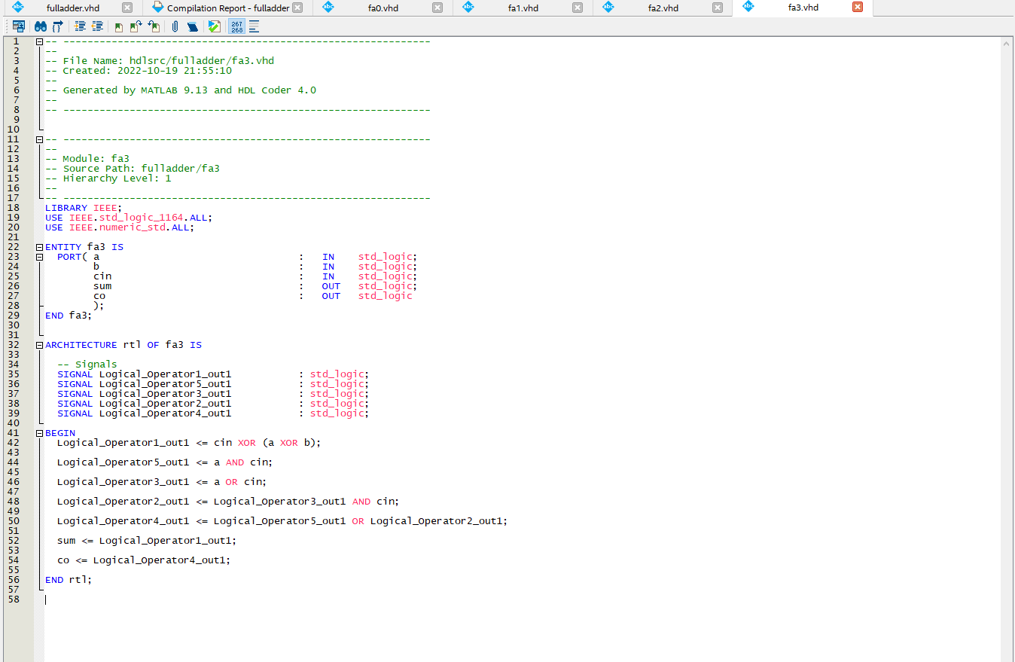
Pin assignment for this program(below screenshot):

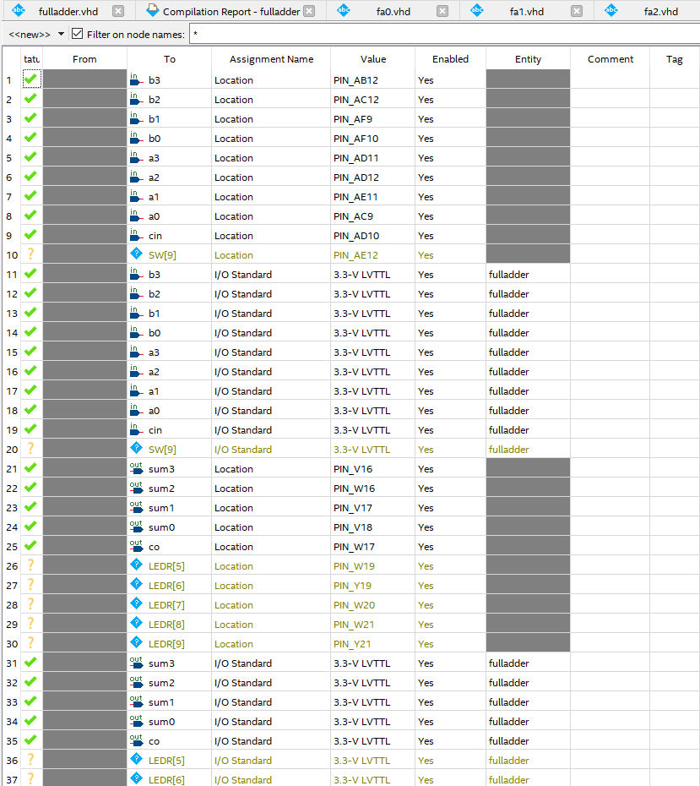
Output Screenshot: Sample screenshots are below
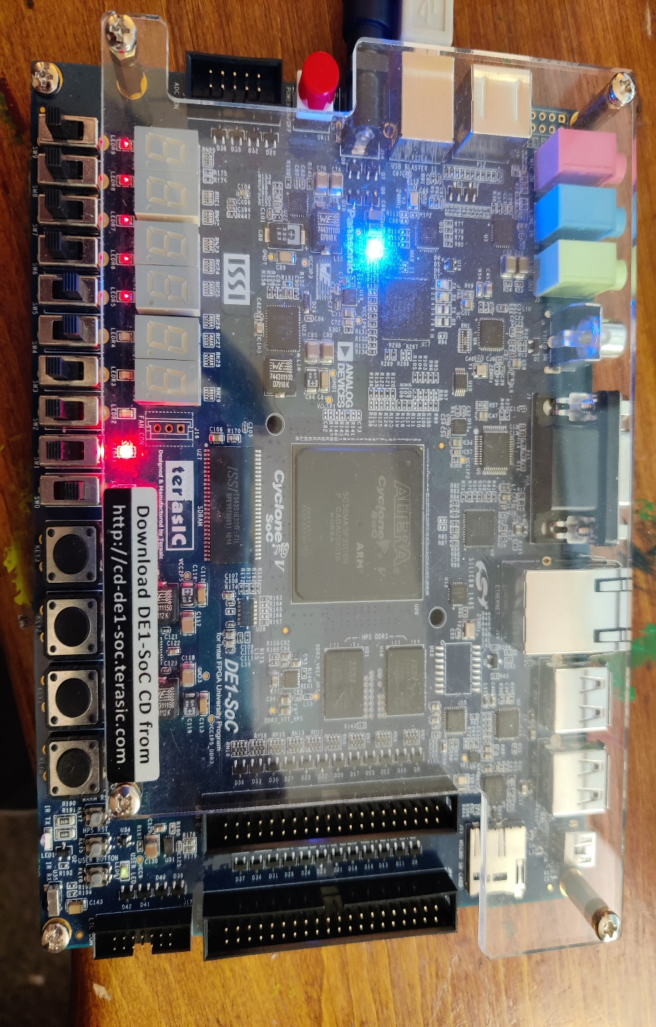
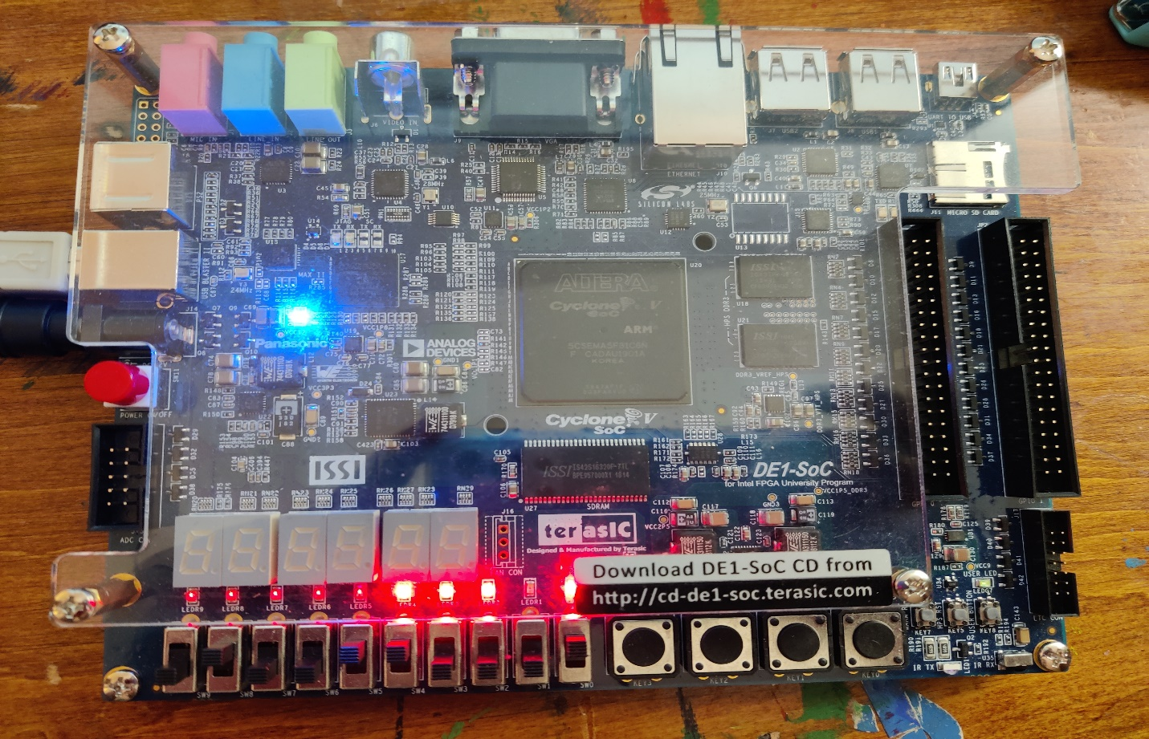
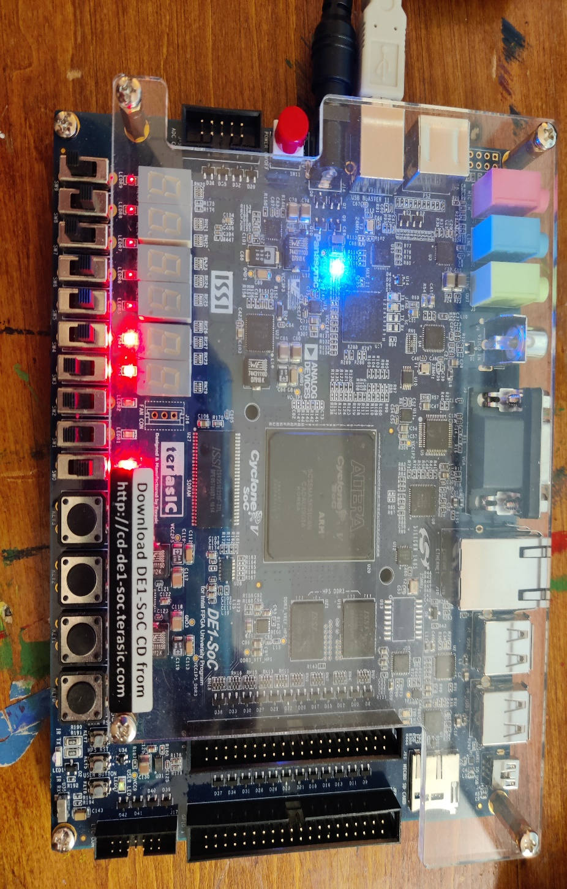
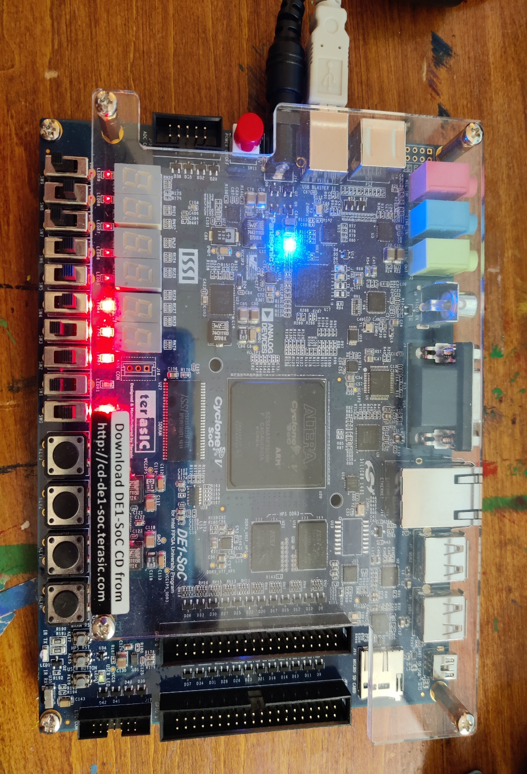
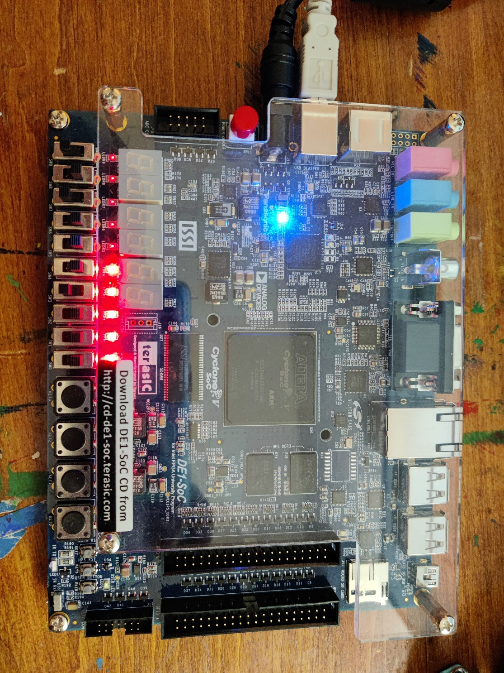

Note: I attach the MATLAB Simulink file inside the hw4 and hw4_fpga is the VHDL code install in the de-soc1 board.

